In-lab exercise

* (80 points) Download and install Cassandra CQL as in the slides:
  + Submit a screenshot of the Cassandra CQL Shell

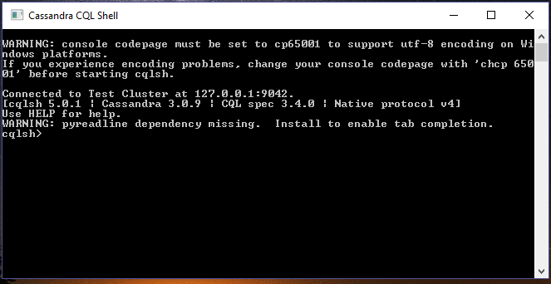

* (20 points) Type the following command to see all the system built-in keyspaces and submit a screenshot of the results:
  + Command : ‘describe tables;’

